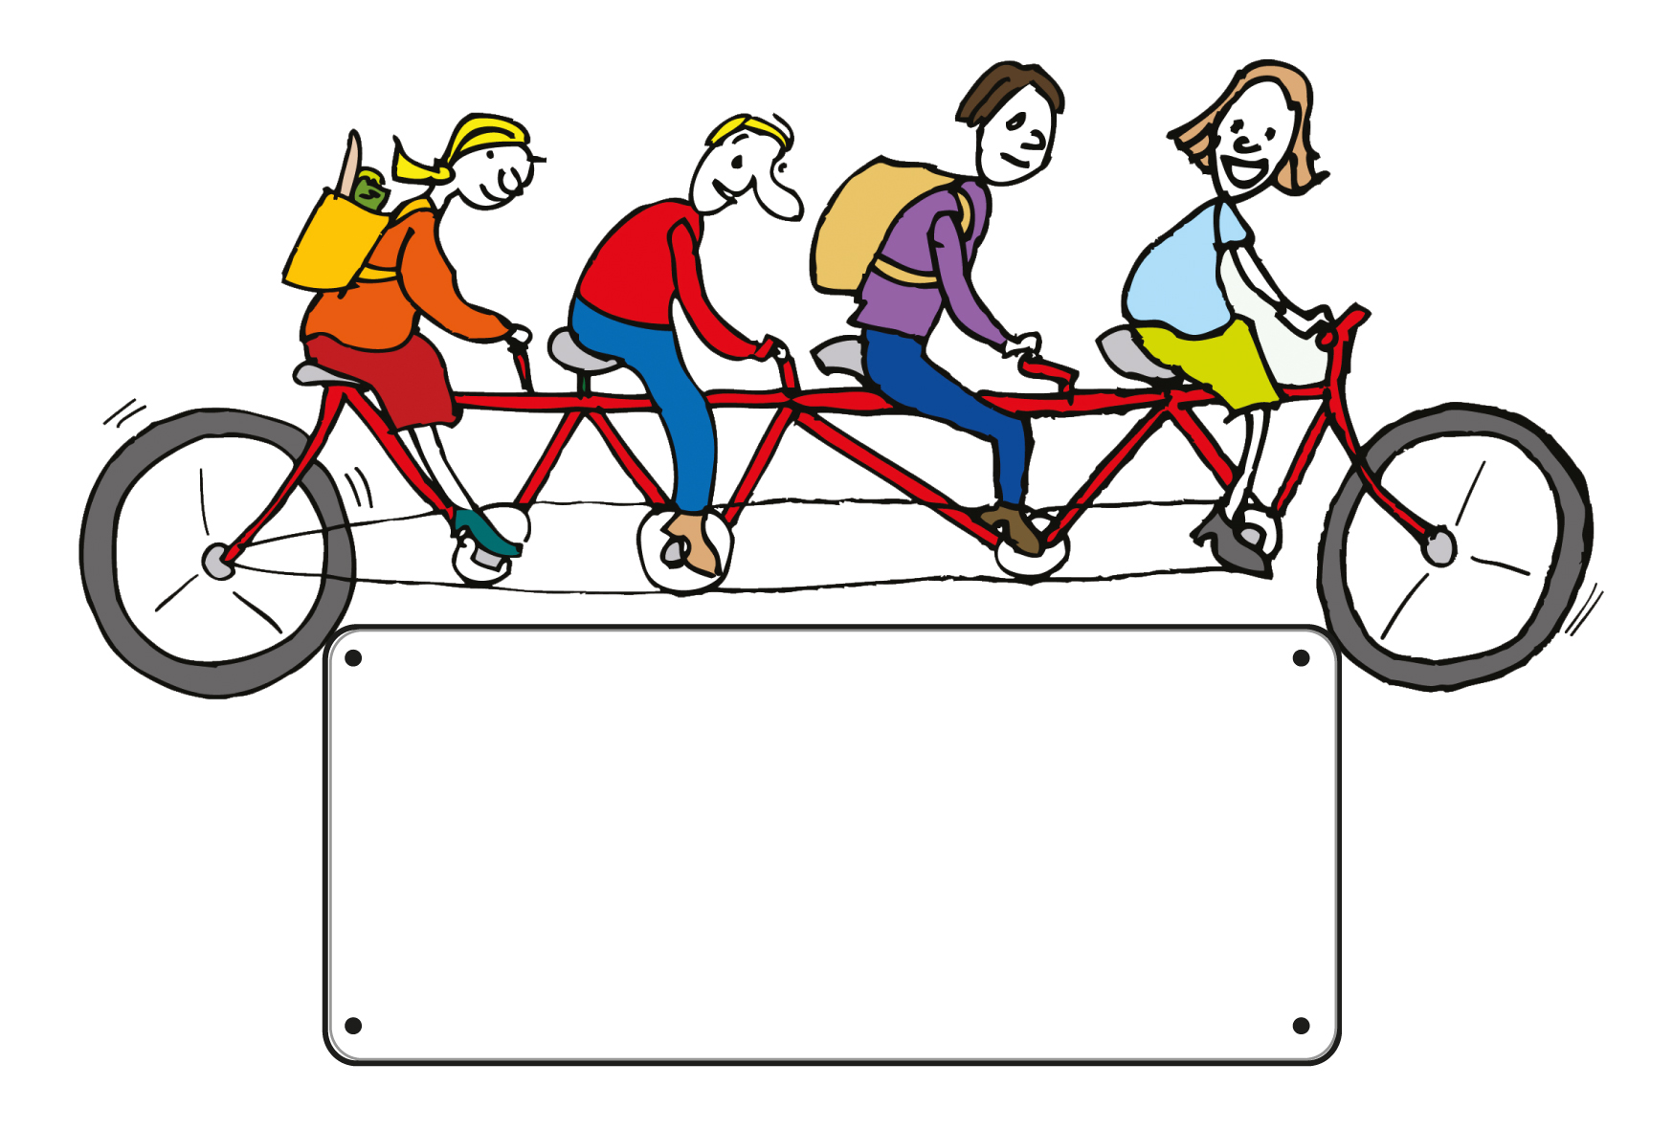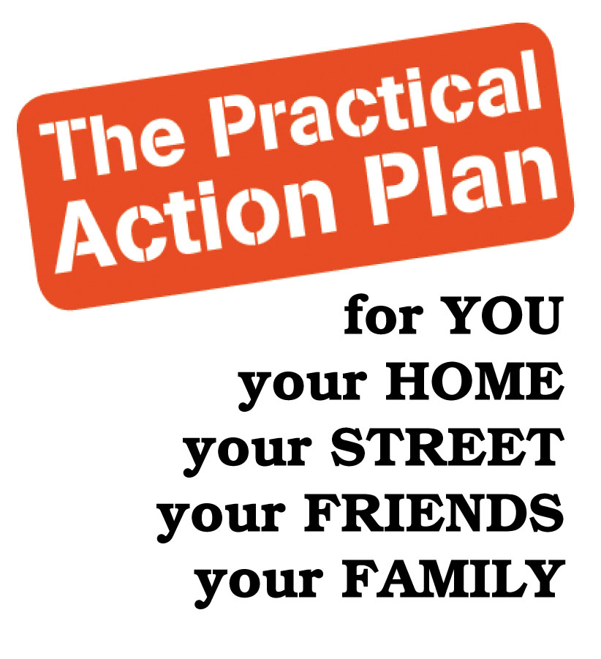

**Cut your household bills** with this new programme that offers straight-forward, practical advice to help you…

* Reduce your energy and water costs
* Understand better these times of change and uncertainty
* Reduce your impact on the environment
* Have fun, make friends and save money

Together with a small group of your friends, family and neighbours you’ll make your way through a workbook packed full of reliable facts, practical tips and very local information relevant to all of us living here in Totnes & District.

Pay nothing – this is programme is free (for the first 100 participants*)!

“The workbook is a great reference, working through it with others stimulates ideas, shares experiences and provides an incentive to change the way we do things. And we’ve made great new relationships which is more than a bonus!” Carole.

Project Name

Next steps: to find out more, join a group in your

neighbourhood, or get some help to start your

own group...

* Call on ……..
* Email us at info@transitiontogether.org.uk
* See us online at www.transitiontogether.org.uk