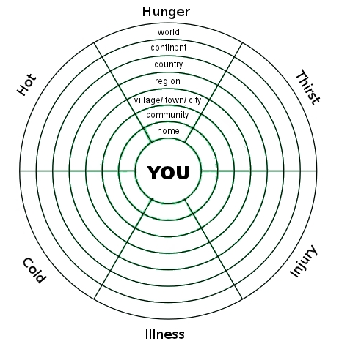
6 ways to die
too hot, too cold, too hungry, too thirsty, ill, injured
Instructions:
- have a think about what infrastructure, services and supplies keep you from dying for each of the 6 ways to die (e.g. food, water, heating, power stations, roads, pipes, wires, drains etc)
- on the circle below, note down where (home, community, etc) such infrastructure, services and supplies are located/ come from.
- ponder what might happen in the future given the realities of climate, energy and economic uncertainty

