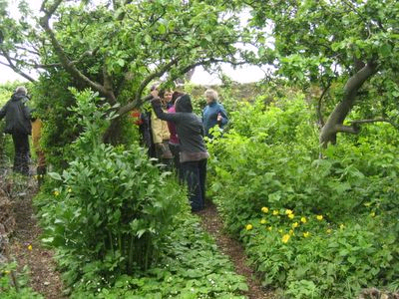
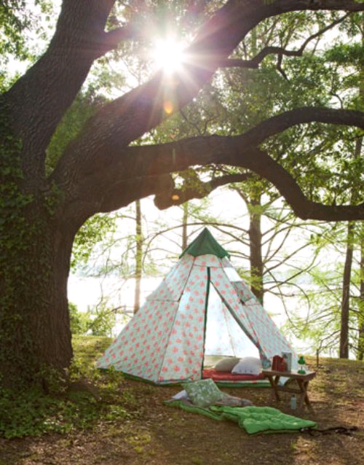

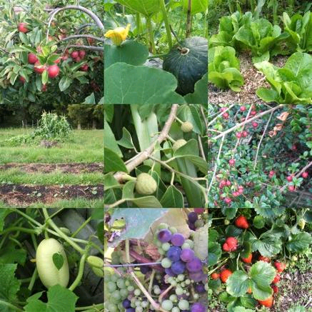
Quadrangle Forest Garden Proposal

The_Business_Case

Vision

To combine camping, forest gardening and education in a design for the main field at the Quadrangle. Working with current best practice to create a replicable model that could be adopted by other landowners with dis- or under- used pasture as a means of increasing yields and income whilst capturing carbon and nutrients.

This would provide the Trust with :
* outdoor classroom space and a hands-on example of Permaculture in practice.
* camping facilities to generate income.
* Low maintenance food production to supply courses and for sale.
* community/ co-operative gardening opportunities for links to local residents.

Needs/ Demand

The design is addressing the following needs -

There is a proven demand for camping space at the Quadrangle, shown through events that JT has been running with Limina and other courses. The camping space will meet a need for low cost options to stay during courses without the laundry and maintenance costs associated with stays in the barn / dormitories.
A demand for outdoor learning space which is now part of the National Curriculum.
A growing interest in low carbon food production and 'grow your own' has created a demand for workshops and places to see practical solutions.
The Trust aims to gather the support of local people and the creation of areas of allotment style growing space will encourage practical involvement.

Benefits

The main benefits identified include:

The increasing price of food and cost of fuel means converting the field into a productive low energy input growing system will provide long term benefits of fruits and fuel wood and non timber products.
The project will provide a platform to educate and facilitate skills exchange within the local and wider community and by deliberately mimicking natural patterns of growth a chance to deepen ecological literacy.
As produce becomes available in larger quantities (years 3+) there will be opportunities for local enterprise in juicing/ drying etc.
The combination of camping space between the growing trees provides for multiple yields, with added value to QT by enhancing the overall offering and creating teaching opportunities.
The camping provides for short term increased income generation which will be able to support set up and maintenance costs. This camping income will continue and be added to by the increasing yields of fruit, herbs and other crops.

Sensitivities/ constraints

* gas pipe – there is a gas main pipe running through field – planting will avoid this area
* neighbours – the design will need to locate camping areas away from sight lines and the booking of campers will need to be managed to avoid loud groups or other disturbance.
* parking – if visitors are unable to arrive by train (highly encouraged) then part of the field may be needed for occasional overflow parking.
* alkaline soil – we have researched appropriate trees for this and have taken advice.
* planning – by not having camping more that 28 days per year no change of use is required.
* water supply – there will need to be piped potable water to the site for handwashing etc.
* fuel supply – the supply of firewood will need to be managed and paid for by campers.

Team
Core Team
* Josef Davies-Coates – Permaculture Design
* Alastair MacKenzie – Permaculture Design
* Jessie Teggin – Design contribution, programming and volunteer co-ordination
* Deborah Wolton – Design contribution and project management

Contributors
* Monica Koncz – project support and learning design for workshops

Partnerships
People who can offer funding, volunteers and work in kind or source funding to participate in the creation and running workshops.

* Co-op including John Keats and other neighbours
* Peramculture Association - already contacted QT re LAND and offering free consultancy
* Shoreham Village School
* Transition Town Sevenoaks
* London Permaculture Network
* Limina
* United Diversity
* Mark Temple (manages four orchards locally)
* Shoreham Society
* Rural Urban Synthesis Society (RUSS)
* West Kent Extra
* Hadlow College
* Steve Charter
* Rochester Young Offenders Institution

milestone/ timeliness

* short term ( 2011)
- design - January mid March
- site prep - Autumn / Winter 2011
- visits - Feburary ongoing – visits to other sites- funding available for research trips.
- implementation - some planting can happen before mid march but main next winter.

* medium - 2- 5 years, ongoing pruning and mulching, tweaking design and adding other plants to increase diversity. Setting up food processing site and researching enterprise options.

* long 5 – 50 years Most trees coming into peak production and some requiring coppicing to manage shading and provide fuel / timber.

Budget (tbc)

Already Secured £500 grant from Permaculture Association

Income streams (draft)
* camping - At £10 per night -

Year 1 28 nights with 2 people staying = £560
Year 2 28 nights with 4 people staying = £1120

* courses in outdoor classroom
- 1st year: 4 Visits in year £100 per time to Trust = £400
- 2nd year: 8 Visits in year = £800

Potential other income -

Profit / Surplus from re-sale of fire wood to campers
Sold at £5 (as per Wowo camp site www.wowo.co.uk) £2 profit per bag,
Year 1 28 bags per year £56
Year 2 56 bags per year £112

* juicing/ drying -
There is potential income from sale of produce to local shop, or to catering for courses. These costings require more work.

Summary
Year 1 potential income - £516 (+500 grant) = £1516
Year 2 potential income - £2032

These are very conservative estimates based on JT and DW not having to put a lot of time and resource into marketing and development of courses.
There is potentially more grant funding for the tree planting and from the West Kent Extra.

Costs:

* plants
215 top fruit trees (delivered from http://www.walcotnursery.co.uk ) £14 per plant
£3010
Soft Fruit, Nut Trees and nitrogen fixers £1000

* tools
5 tree planting spades at £15 each = £75

70p per 1m stake (ww.acorn-planting-products.com-) =£154

Rabbit protectors – £1.20 each £264

* experts
Soil analysis £120 ?

* volunteer expenses
Providing refreshments for 15 people for 4 planting days
estimated £5 per person per day = £300 (could be offset by asking people to bring food)

* team expenses
Travel - London £13 return on train.
Design and implement phase - weekly visits by 2 designers for 4 months = £312

TOTAL £8398 (including 10% contingency)

