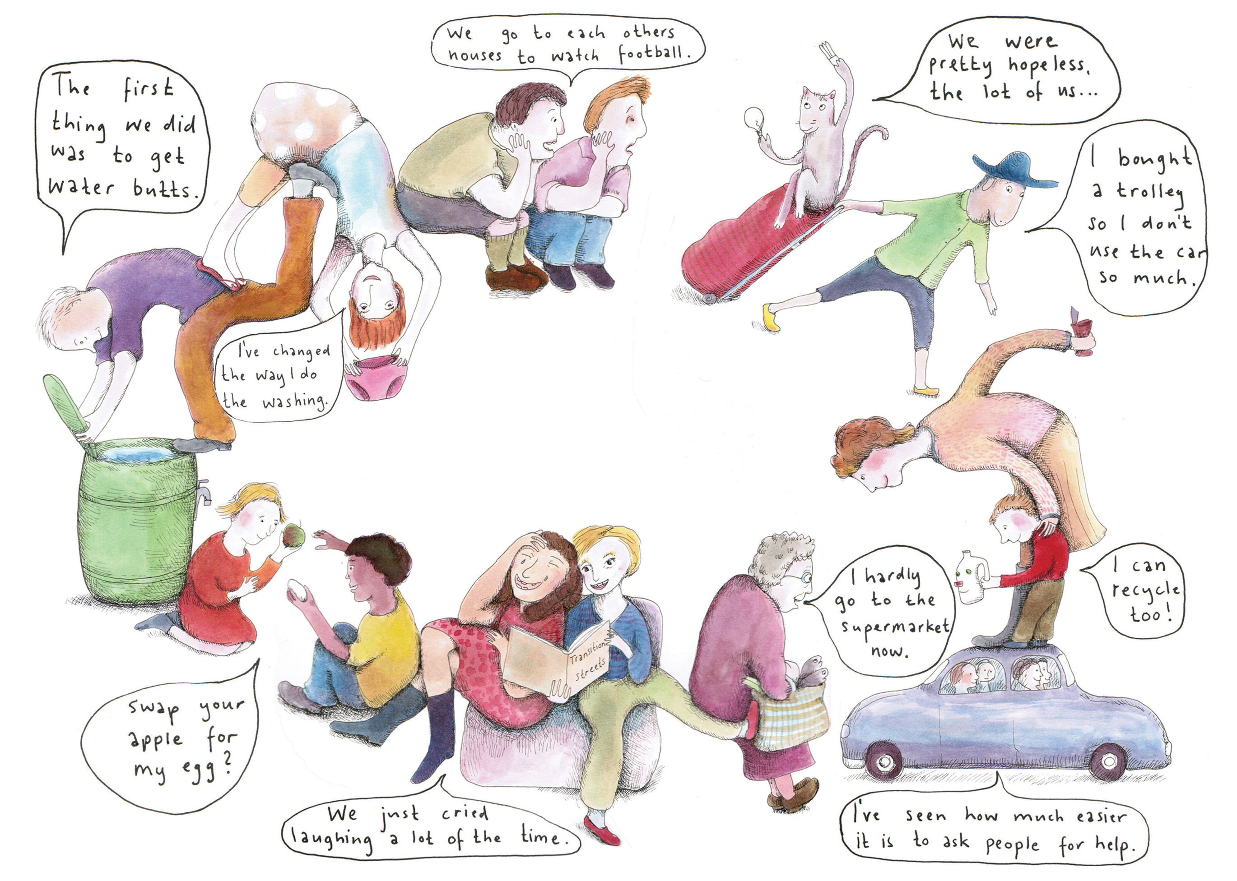

Groups of friends and neighbours meet every few weeks with a practical workbook to make easy changes in how they use energy, water, food, packaging

and transport

Leaflet illustrations by Claudia Schmid. Quotes from Transition Streets participants, Social Impact Report (2011) at www.transitionstreets.org