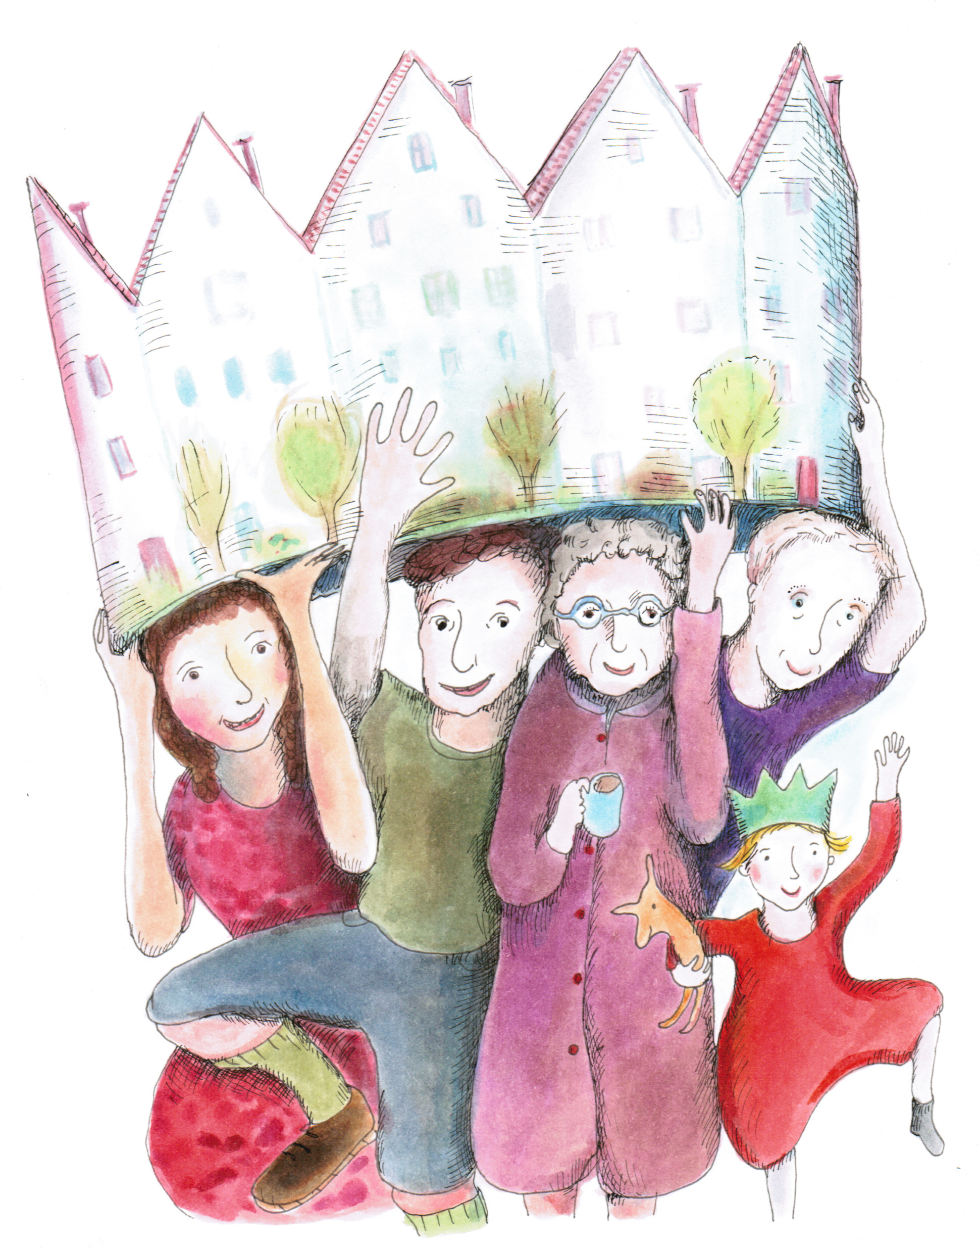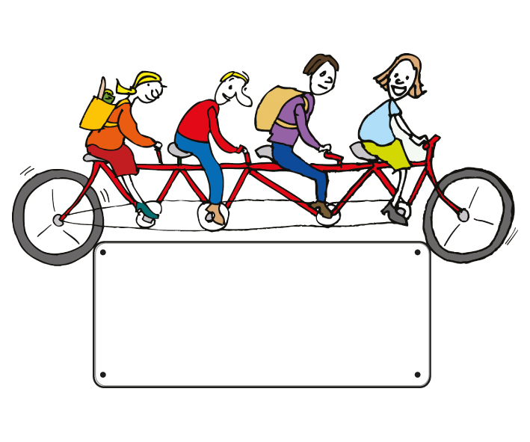

*‘Best thing that has happened to us since we moved in 1974’*

Organisation

Name

**Get together with your neighbours**

**Save money**

**Cut your carbon footprint**

You can save £570 a year on your household bills, cut your CO2 emissions by 1.2 tonnes and get to know your neighbours better – all in the award-winning Transition Streets project.

Ask six neighbours and friends who live near you if they’d like to form a Transition Streets group, and we’ll give you workbooks and a facilitator to get you started.

01803 867358

email address….

Website address…