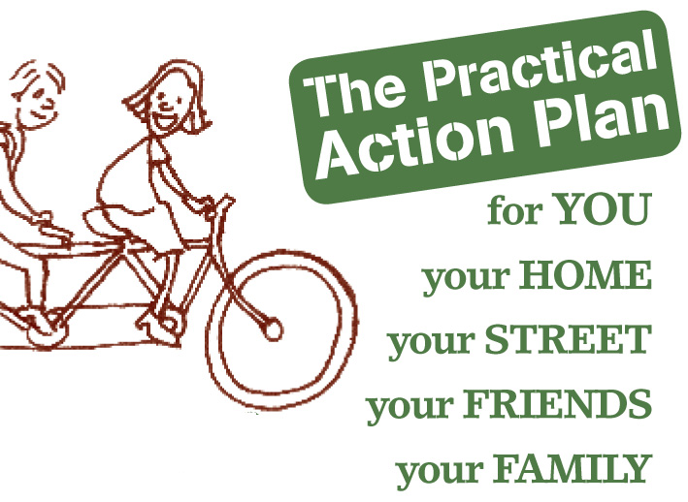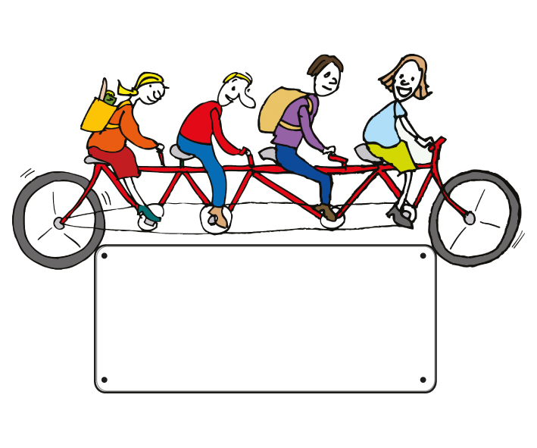

**How does it work?**

**Your own practical workbook to study with a group of**

**friends, neighbours or colleagues.**

Over a course of **7 sessions** exploring practical ways to control your usage and cut your bills in 5 key areas:

**Energy Water Food**

**Waste Transport**

Special offers on energy saving equipment for home DIY

Work at a pace and schedule to suit you and your group

No membership fee, no subscription, no charges

**Join up today**

**0000000000**

email address

website address

Organisation

Name

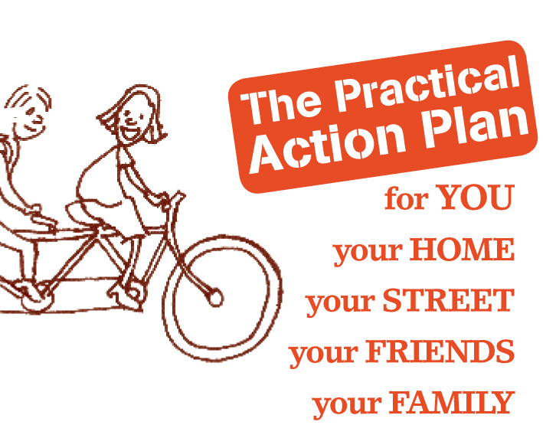

**Cut your**

**household bills**

**With this new programme that offers easy, helpful, practical advice enabling you to**

* take control of your daily costs
* understand better these times of change and uncertainty
* reduce your impact on the environment
* act together with your friends, family and community
* have fun, make friends and save money at a pace and schedule that suits you
* pay nothing - this programme is free

Organisation

Name

**Join up today**

**0000000000**

email address

website address